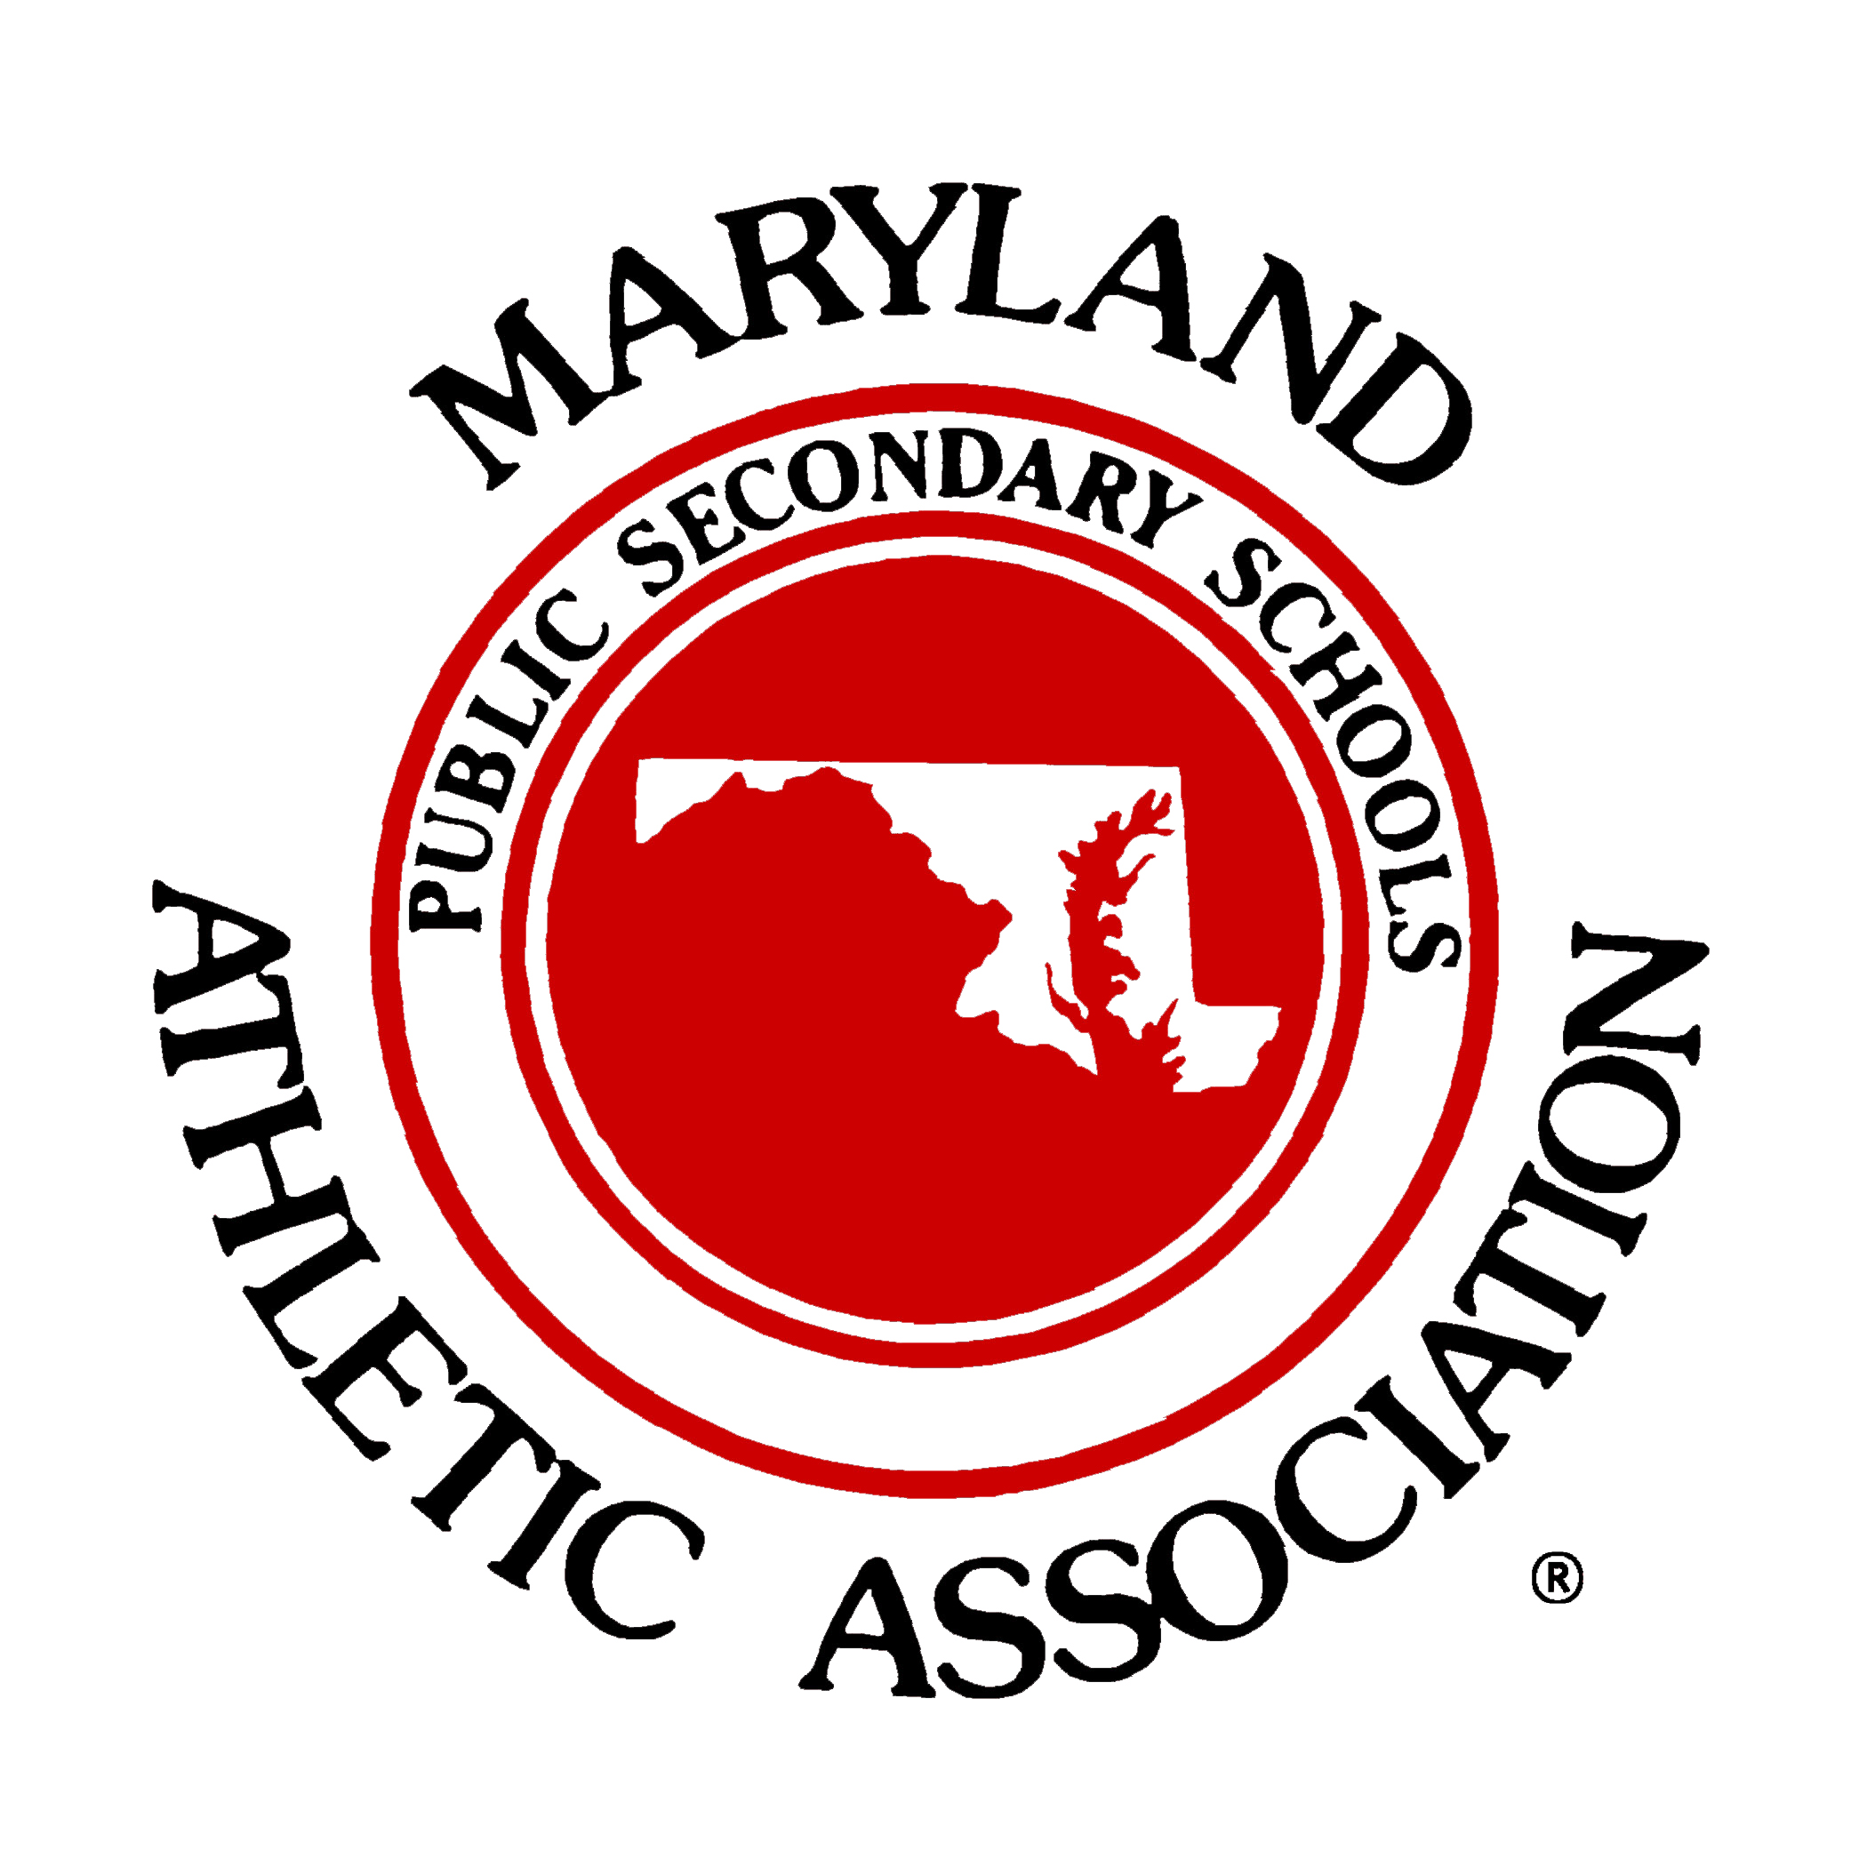
PA Announcement
(To be used during distribution of magnets)

In recent years much has been learned regarding the seriousness
of concussion and the precautions needed prior to returning to play.
As part of “Concussion Awareness Week” the Maryland Public
Secondary Schools Athletic Association in conjunction with

________________________ (and)___________________________
(County Name) (High School Name)

are providing complementary refrigerator magnets to families of
(football, boys soccer and girls soccer) players as a reminder and a
(select one)

resource should the need ever arise.

Please direct your attention to (midfield, home bench, end zone, etc.)
(select one)

Where _________________________, ______________________________
(Name) (Principal, AD, Trainer, etc.)
(Title)

of _______________________________
(High School Name)
will provide a reminder magnet to representatives of each
__________________________________ family.
(football, boys soccer, girls soccer)
(select one)

Realizing the potential for significant complications following an
initial concussion the best advice is “When in doubt-Sit them out.”

